Tracing The
Modus Operandi
Of The
Social Unconscious;
The Anorexic Paradigm
******

Joshua Lavie
The Israeli Institute of group Analysis
Forum Institute for Psychotherapy, Tel Aviv
Tel Aviv University

In Feb and Mar 1965 SHF was consultant for UNESCO in Israel, mainly to advise to school psychological services. He gave a lecture at the Hebrew University of Jerusalem on Monday February 22, 1965. Here are Foulkes's own words (1965):

“Social psychologists and cultural anthropologists have made us familiar with an abundance of observations showing beautifully how all individuals are conditioned to their community. There is quite a considerable resistance against such a perspective, that the ego and the superego, the very core of the personality, are socially conditioned, as soon as it becomes real and concrete in our daily lives and profession!"
Modern man clings anxiously to his individuality and identity, and quite erroneously assumes these [individuality and identity J.L.] to be threatened by such observations, instead of realizing that they are threatened, on the contrary, by the rift between the group and its individuals in our culture."
This transmission [of the rift, J.L.] from generation to generation is an unconscious process. The individual tends to remain unconscious of it [the transmission, J.L] in his own person, and well defended against its recognition."
"I have called this [the above combinations of complementary processes, J.L.] the ‘Social Unconscious’."
"The ego cannot see itself, just as one cannot look into one’s own eyes, except in a mirror.”
(1965; published in 2003 pp: 85-86)

Foulkes displayed his fundamental conception of the Modus Operandi of the 'Social Unconscious' emphasizing the mental acts and social processes in the following six steps, so here are my words as a paraphrase to Foulkes:

- Modern man's resistance against his social nature
- Modern man's false assumption about the pseudo threat stemming from his social nature
- Modern man's idealization of his self-identity and anxious clinging to his supreme individuality
- Modern man's splitting the group from its individuals
- Modern man's denying the real threat which derives from this split between the group and its individuals in our modern culture
- Cultural transmission of the above mental and social processes from generation to generation

This combination of mental acts (feelings, beliefs, defenses, inversions, misconceptions), constitute the Modus Operandi of the Social Unconscious.

Some of the steps that characterize the modus operandi of the social unconscious in general, as Foulkes indicated, characterize the modus operandi in eating disorders: anorexia, bulimia.

But before referring to eating disorders in general and anorexia in particular let's talk about the body. If usually we talk about self and society; or about individual-self versus society; or about, as Norbert Elias had put it ingeniously, 'society of individuals; I want to refer first to S. H. Foulkes and his deep insight to the fundamental place of the human body in the world of human social relations, and second to some of the representative scholars of the post modern era; I mean to Susan Bordo, Pierre Bourdieu and Michel Foucault.

Foulkes on the Body (1969):

"After all, there is hardly any internal experience possible which has not been stimulated from outside and by other people; even the experience of our own bodies has from the first been imbued with the influence of our mothers (which are themselves part of our culture, J.L.)".

Susan Bordo on the Body (1993):

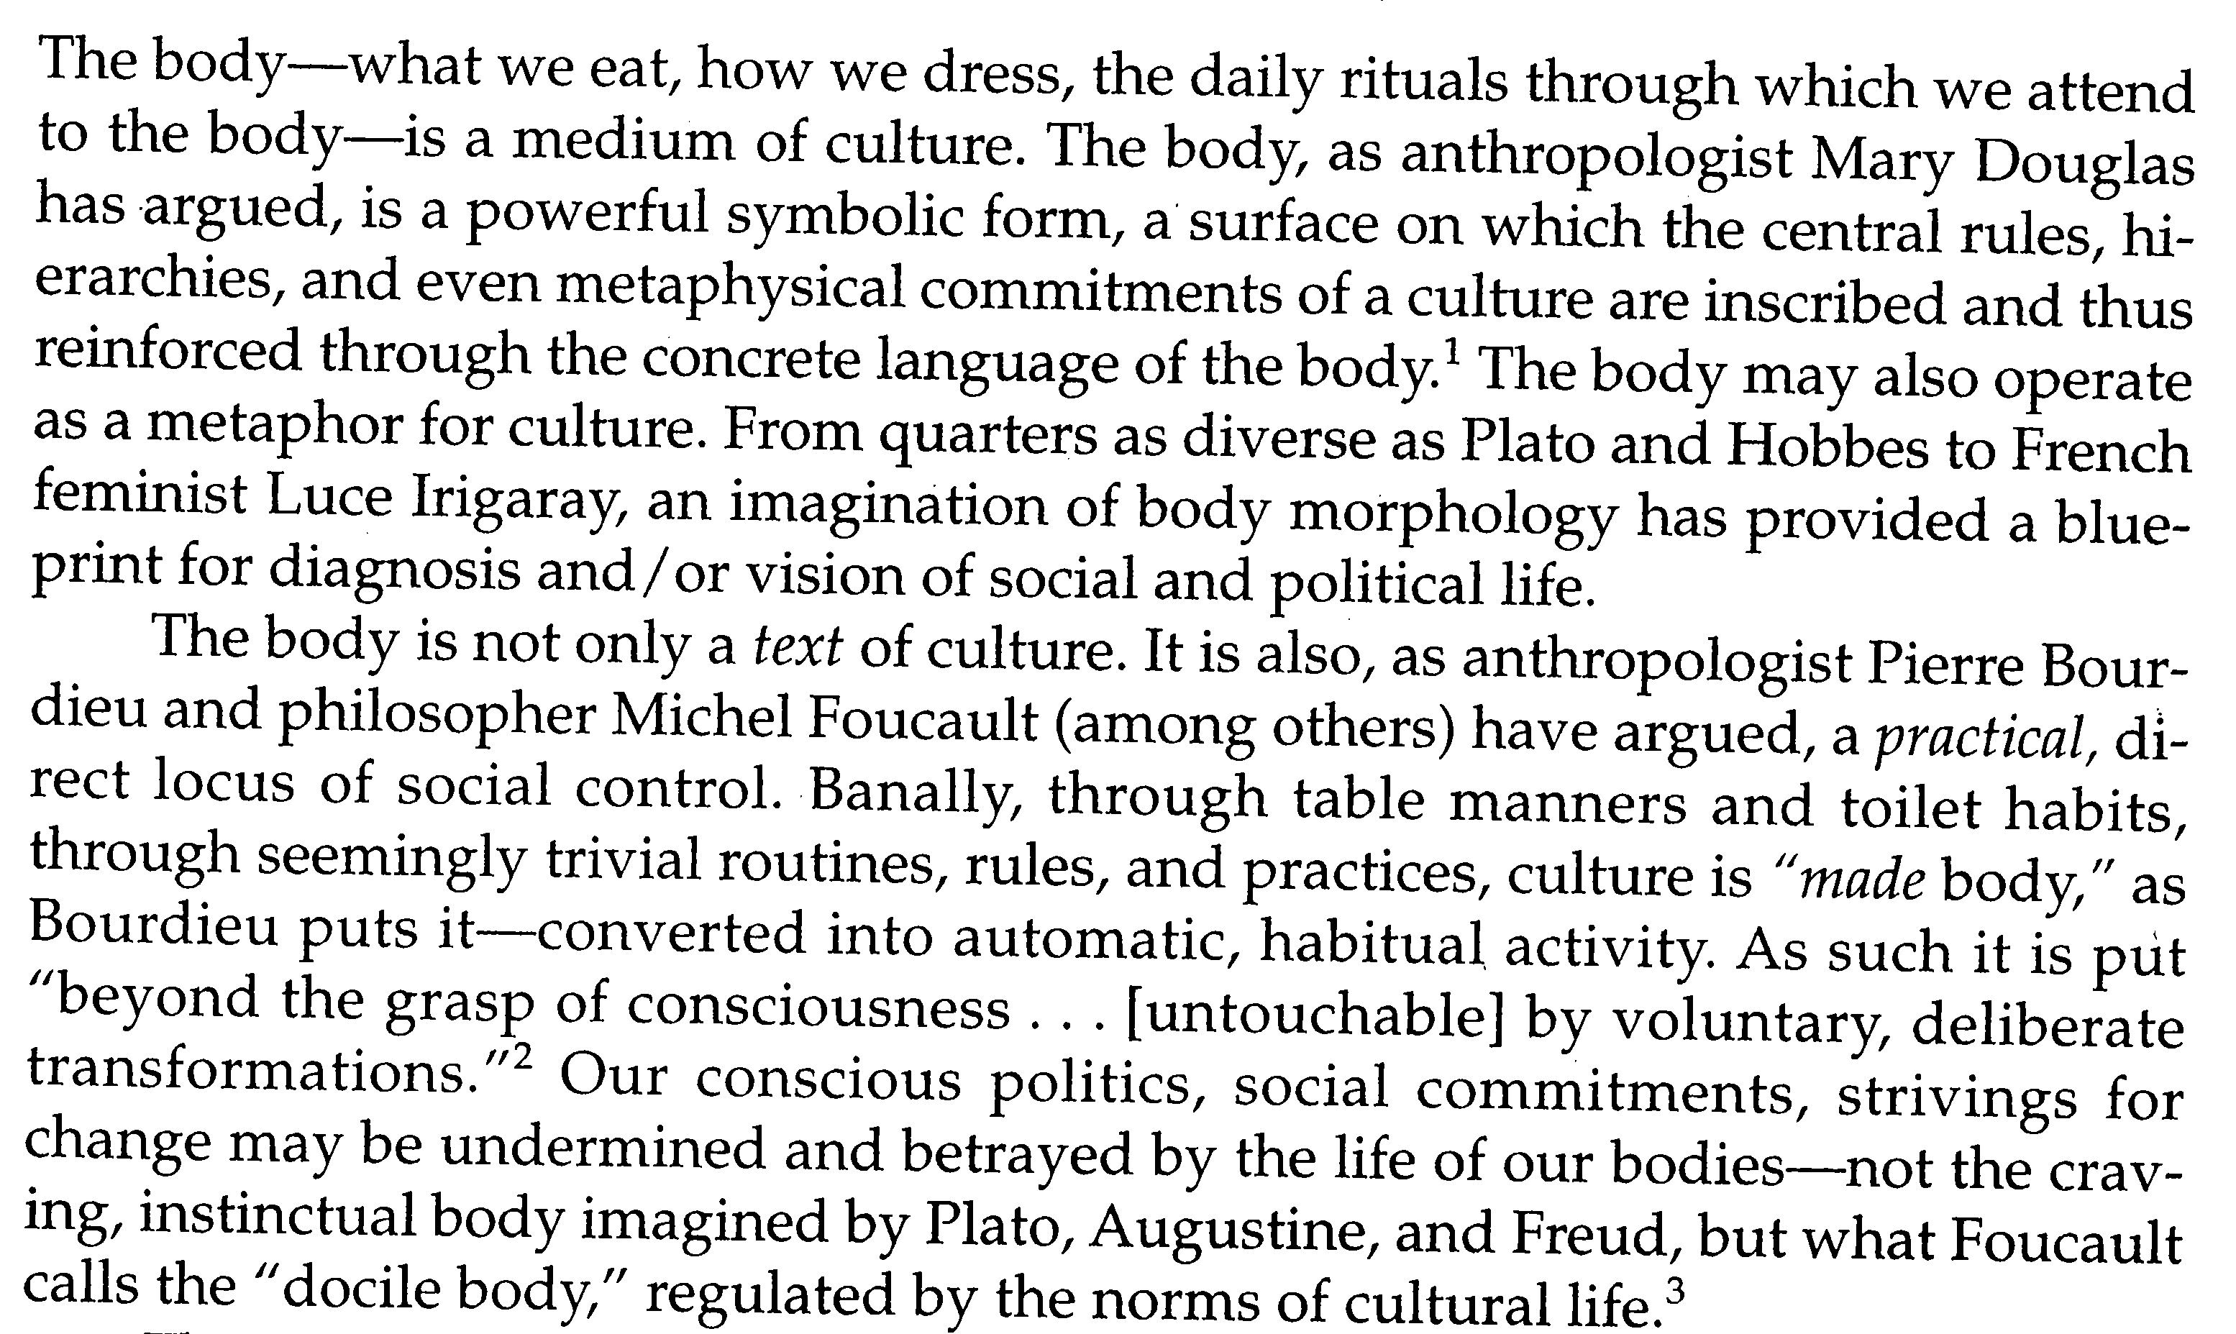

Now, in eating disorders the body serves as a site for the modus operandi of the social unconscious. Here in this site we can see how women:

- Resist and deny the appetites of their tangible female bodies.
- Develop false assumptions that through dieting or intense bodily exercise they will materialize their individual identity
- Idealize skinniness and thinness and cling to the tyranny of the beauty myth as a false promise for happiness
- Split their feminine appetites from their ambitions to perform and succeed (thus falling back to the trap of the masculine discourse)
- Deny the real threat which derives from this split between their common female bodies and their individual desires
- Cultural transmission of the above mental and social operations from generation to generation (mothers to daughters to sisters)

The gist of the modus operandi of the social unconscious is:
- Resisting and denying a factual reality about human body/mind/society
- After the denial is implanted and becomes a "truth", people of a specific culture in a specific era develop false assumptions about what is beneficial or what is harmful to themselves
- Transmission of this complex processes from generation to generation.

Susan Bordo accurately describes this process:

UNESCO = United Nations Economic Social and Cultural Organization

